Chapter 1

Introduction

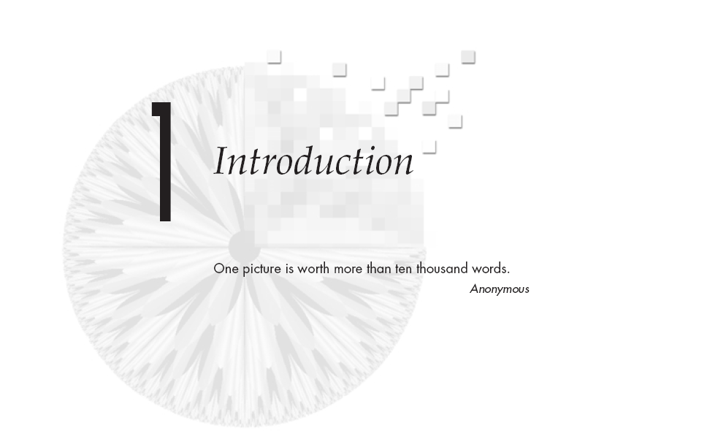

# 1.1 Image

An image (from [Latin](http://en.wikipedia.org/wiki/Latin_language): *imago*) is an artifact, for example a [two-dimensional](http://en.wikipedia.org/wiki/Two-dimensional) picture, that has a similar appearance to some [subject](http://en.wikipedia.org/wiki/Subject_%28philosophy%29)—usually a physical object or a [person](http://en.wikipedia.org/wiki/Person).

* + 1. **Characteristics**

Images may be two-[dimensional](http://en.wikipedia.org/wiki/Dimension), such as a [photograph](http://en.wikipedia.org/wiki/Photograph), screen display, and as well as a three-dimensional, such as a [statue](http://en.wikipedia.org/wiki/Statue) or [hologram](http://en.wikipedia.org/wiki/Hologram). They may be *captured* by [optical](http://en.wikipedia.org/wiki/Optics) devices—such as [cameras](http://en.wikipedia.org/wiki/Camera), [mirrors](http://en.wikipedia.org/wiki/Mirror), [lenses](http://en.wikipedia.org/wiki/Lens_%28optics%29), [telescopes](http://en.wikipedia.org/wiki/Telescope), [microscopes](http://en.wikipedia.org/wiki/Microscope), etc., And natural objects and phenomena, such as the [human eye](http://en.wikipedia.org/wiki/Human_eye) or water surfaces.

The word *image* is also used in the broader sense of any two-dimensional figure such as a [map](http://en.wikipedia.org/wiki/Map), a [graph](http://en.wikipedia.org/wiki/Graph_%28data_structure%29), a [pie chart](http://en.wikipedia.org/wiki/Pie_chart), or an [abstract painting](http://en.wikipedia.org/wiki/Abstract_art). In this wider sense, images can also be *rendered* manually, such as by [drawing](http://en.wikipedia.org/wiki/Drawing), [painting](http://en.wikipedia.org/wiki/Painting), [carving](http://en.wiktionary.org/wiki/carving), rendered automatically by [printing](http://en.wikipedia.org/wiki/Printing) or [computer graphics](http://en.wikipedia.org/wiki/Computer_graphics) technology, or [developed](http://en.wikipedia.org/wiki/Image_development_%28visual_arts%29) by a combination of methods, especially in a [pseudo-photograph](http://en.wikipedia.org/wiki/Pseudo-photograph).

* + 1. **Moving image**

A moving image is typically a movie ([film](http://en.wikipedia.org/wiki/Film)), or [video](http://en.wikipedia.org/wiki/Video), including [digital video](http://en.wikipedia.org/wiki/Digital_video). It could also be an animated display such as a [zoetrope](http://en.wikipedia.org/wiki/Zoetrope).

**1.2 Digital image**

A digital image is a numeric representation (normally [binary](http://en.wikipedia.org/wiki/Binary_numeral_system)) of a two-dimensional [image](http://en.wikipedia.org/wiki/Image). Depending on whether or not the [image resolution](http://en.wikipedia.org/wiki/Image_resolution) is fixed, it may be of [vector](http://en.wikipedia.org/wiki/Vector_graphics) or [raster](http://en.wikipedia.org/wiki/Raster_graphics) type. Without qualifications, the term "digital image" usually refers to [raster images](http://en.wikipedia.org/wiki/Raster_image) also called bitmap images.

In other word - An image consisting of data (specifically a set of elements) defined on an *n*-dimensional regular grid that has the potential for display. These elements are referred to as pixels. The pixels in different images may represent a variety of types of information, such as temperature, pressure, velocity, terrain height, or tissue density. The regular grid is frequently over a two-dimensional space but can be three-dimensional, and even four-dimensional if sampling over time is also included. .

**1.2.1 Raster image**

[Raster images](http://en.wikipedia.org/wiki/Raster_image) have a finite set of [digital](http://en.wikipedia.org/wiki/Digital) values, called *picture elements* or [pixels](http://en.wikipedia.org/wiki/Pixel). The digital image contains a fixed number of rows and columns of pixels. Pixels are the smallest individual element in an image, holding quantized values that represent the brightness of a given color at any specific point.

Typically, the pixels are stored in computer memory as a [raster image](http://en.wikipedia.org/wiki/Raster_graphics) or raster map, a two-dimensional array of small integers. These values are often transmitted or stored in a [compressed](http://en.wikipedia.org/wiki/Image_compression) form.

**1.2.1.1 Raster image types**

Each pixel of a raster image is typically associated to a specific 'position' in some 2D region, and has a *value* consisting of one or more quantities ([samples](http://en.wikipedia.org/wiki/Sample_%28signal%29)) related to that position. Digital images can be classified according to the number and nature of those samples:

* [Binary](http://en.wikipedia.org/wiki/Binary_image)
* [Gray-scale](http://en.wikipedia.org/wiki/Grayscale)
* [Color](http://en.wikipedia.org/wiki/Color_image)
* [False-color](http://en.wikipedia.org/wiki/False-color_image)
* [Multi-spectral](http://en.wikipedia.org/wiki/Multi-spectral_image)
* [Thematic](http://en.wikipedia.org/wiki/Thematic_image)
* [Picture function](http://en.wikipedia.org/wiki/Picture_function)

**1.2.1.2 Raster file formats**

Most users come into contact with raster images through digital cameras. Some [digital cameras](http://en.wikipedia.org/wiki/Digital_camera) give access to almost all the data captured by the camera, using a [raw image format](http://en.wikipedia.org/wiki/Raw_image_format). *The Universal Photographic Imaging Guidelines (UPDIG)* suggests this format be used when possible since raw files produce the best quality images. These file formats allow the photographer and the processing agent the greatest level of control and accuracy for output. Their use is inhibited by the prevalence of proprietary information ([trade secrets](http://en.wikipedia.org/wiki/Trade_secrets)) for some camera makers, but organizations are attempting to influence manufacturers to release these records publicly. An alternative may be a [Digital Negative (DNG)](http://en.wikipedia.org/wiki/Digital_Negative_%28file_format%29) a proprietary Adobe product described as “the public, archival format for digital camera raw data”. Although this format is not yet universally accepted, support for the product is growing and archival confidence is building.

**1.2.2 Vector image**

[Vector images](http://en.wikipedia.org/wiki/Vector_image) resulted from mathematical geometry ([vector](http://en.wikipedia.org/wiki/Vector)). In mathematical term, a vector consists of point that has direction and length.

Often, both raster and vector elements will be combined in one image, for example, in the case of a billboard with text (vector) and photographs (raster).

|  |  |
| --- | --- |
| **1.2.3 Image viewing** |  |

The user can utilize different program to see the image. The [GIF](http://en.wikipedia.org/wiki/Graphics_Interchange_Format), [JPEG](http://en.wikipedia.org/wiki/JPEG), and [PNG](http://en.wikipedia.org/wiki/Portable_Network_Graphics) images can be seen simply using a [web browser](http://en.wikipedia.org/wiki/Web_browser) because they are the standard internet image formats. The [SVG](http://en.wikipedia.org/wiki/Scalable_Vector_Graphics) format is more and more used in the web and is a standard [W3C](http://en.wikipedia.org/wiki/W3C) format.

**1.2.4 History of Digital image**

Early [Digital fax](http://en.wikipedia.org/wiki/Fax_machine#Digital) machines such as the [Bart lane cable picture transmission system](http://en.wikipedia.org/wiki/Bartlane_cable_picture_transmission_system) preceded digital cameras and computers by decades. The first picture to be scanned, stored, and recreated in digital pixels was displayed on the Standards Eastern Automatic Computer at [NIST](http://en.wikipedia.org/wiki/NIST). The advancement of digital imagery continued in the early 1960s, alongside development of the [space program](http://en.wikipedia.org/wiki/Space_program) and in [medical](http://en.wikipedia.org/wiki/Medicine) research. Projects at the [Jet Propulsion Laboratory](http://en.wikipedia.org/wiki/Jet_Propulsion_Laboratory), [MIT](http://en.wikipedia.org/wiki/MIT), [Bell Labs](http://en.wikipedia.org/wiki/Bell_Labs) and the [University of Maryland](http://en.wikipedia.org/wiki/University_of_Maryland,_College_Park), among others, used digital images to advance [satellite imagery](http://en.wikipedia.org/wiki/Satellite_imagery), wire photo standards conversion, [medical imaging](http://en.wikipedia.org/wiki/Medical_physics), [videophone](http://en.wikipedia.org/wiki/Videophone) technology, [character recognition](http://en.wikipedia.org/wiki/Character_recognition), and photo enhancement.

Rapid advances in digital imaging began with the introduction of [microprocessors](http://en.wikipedia.org/wiki/Microprocessor) in the early 1970s, alongside progress in related storage and display technologies. The invention of computerized axial tomography ([CAT scanning](http://en.wikipedia.org/wiki/CAT_scanning)), using [x-rays](http://en.wikipedia.org/wiki/X-ray) to produce a digital image of a "slice" through a three-dimensional object, was of great importance to medical diagnostics. As well as origination of digital images, [digitization](http://en.wikipedia.org/wiki/Digitization) of analog images allowed the enhancement and restoration of [archaeological](http://en.wikipedia.org/wiki/Archaeology) artifacts and began to be used in fields as diverse as [nuclear medicine](http://en.wikipedia.org/wiki/Nuclear_medicine), [astronomy](http://en.wikipedia.org/wiki/Astronomy), [law enforcement](http://en.wikipedia.org/wiki/Law_enforcement_agency), [defense](http://en.wikipedia.org/wiki/Defence_%28military%29) and [industry](http://en.wikipedia.org/wiki/Industry).

**1.3 Digital image processing**

Digital image processing is the use of computer [algorithms](http://en.wikipedia.org/wiki/Algorithm) to perform [image processing](http://en.wikipedia.org/wiki/Image_processing) on [digital images](http://en.wikipedia.org/wiki/Digital_image). As a subcategory or field of [digital signal processing](http://en.wikipedia.org/wiki/Digital_signal_processing), digital image processing has many advantages over [analog image processing](http://en.wikipedia.org/wiki/Analog_image_processing). It allows a much wider range of algorithms to be applied to the input data and can avoid problems such as the build-up of noise and signal distortion during processing. Since images are defined over two dimensions (perhaps more) digital image processing may be modeled in the form of [Multidimensional Systems](http://en.wikipedia.org/wiki/Multidimensional_Systems).

**1.3.1 History**

Many of the techniques of digital image processing, or digital picture processing as it often was called, were developed in the 1960s at the [Jet Propulsion Laboratory](http://en.wikipedia.org/wiki/Jet_Propulsion_Laboratory), [Massachusetts Institute of Technology](http://en.wikipedia.org/wiki/MIT), [Bell Laboratories](http://en.wikipedia.org/wiki/Bell_Laboratories), [University of Maryland](http://en.wikipedia.org/wiki/University_of_Maryland,_College_Park), and a few other research facilities, with application to [satellite imagery](http://en.wikipedia.org/wiki/Satellite_imagery), wire-photo standards conversion, [medical imaging](http://en.wikipedia.org/wiki/Medical_physics), [videophone](http://en.wikipedia.org/wiki/Videophone), [character recognition](http://en.wikipedia.org/wiki/Character_recognition), and photograph enhancement.[[1]](http://en.wikipedia.org/wiki/Digital_image_processing#cite_note-0) The cost of processing was fairly high, however, with the computing equipment of that era. That changed in the 1970s, when digital image processing proliferated as cheaper computers and dedicated hardware became available. Images then could be processed in real time, for some dedicated problems such as [television standards conversion](http://en.wikipedia.org/wiki/Television_standards_conversion). As general-purpose computers became faster, they started to take over the role of dedicated hardware for all but the most specialized and computer-intensive operations.

With the fast computers and signal processors available in the 2000s, digital image processing has become the most common form of image processing and generally, is used because it is not only the most versatile method, but also the cheapest.

**1.3.2 Tasks**

Digital image processing allows the use of much more complex algorithms for image processing, and hence, can offer both more sophisticated performance at simple tasks, and the implementation of methods which would be impossible by analog means.

In particular, digital image processing is the only practical technology for:

* [Classification](http://en.wikipedia.org/wiki/Statistical_classification)
* [Feature extraction](http://en.wikipedia.org/wiki/Feature_extraction)
* [Pattern recognition](http://en.wikipedia.org/wiki/Pattern_recognition)
* [Projection](http://en.wikipedia.org/wiki/Projection)
* [Multi-scale signal analysis](http://en.wikipedia.org/wiki/Multi-scale_signal_analysis)

Some techniques which are used in digital image processing include:

* [Pixelization](http://en.wikipedia.org/wiki/Pixelization)
* [Linear filtering](http://en.wikipedia.org/wiki/Linear_filter)
* [Principal components analysis](http://en.wikipedia.org/wiki/Principal_components_analysis)
* [Independent component analysis](http://en.wikipedia.org/wiki/Independent_component_analysis)
* [Hidden Markov models](http://en.wikipedia.org/wiki/Hidden_Markov_model)
* [Anisotropic diffusion](http://en.wikipedia.org/wiki/Anisotropic_diffusion)
* [Partial differential equations](http://en.wikipedia.org/wiki/Partial_differential_equations)
* [Self-organizing maps](http://en.wikipedia.org/wiki/Self-organizing_map)
* [Neural networks](http://en.wikipedia.org/wiki/Artificial_neural_networks)
* [Wavelets](http://en.wikipedia.org/wiki/Wavelet)

**1.3.3 Applications**

### 1.3.3.1 Digital camera images

Digital cameras generally include dedicated digital image processing chips to convert the raw data from the image sensor into a color-corrected image in a standard image file format. Images from digital cameras often receive further processing to improve their quality, a distinct advantage that digital cameras have over film cameras. The digital image processing typically is executed by special software programs that can manipulate the images in many ways.

### 1.3.3.2 Film

[West world](http://en.wikipedia.org/wiki/Westworld) (1973) was the first feature film to use digital image processing to [pixelate](http://en.wikipedia.org/wiki/Pixellate) photography to simulate an android's point of view.

### 1.3.3.3 Intelligent transportation systems

Digital image processing has a wide application in intelligent transportation systems, such as [automatic number plate recognition](http://en.wikipedia.org/wiki/Automatic_number_plate_recognition) and [traffic sign recognition](http://en.wikipedia.org/wiki/Traffic_sign_recognition).

**1.4 Fundamental Steps in Digital Image Processing**

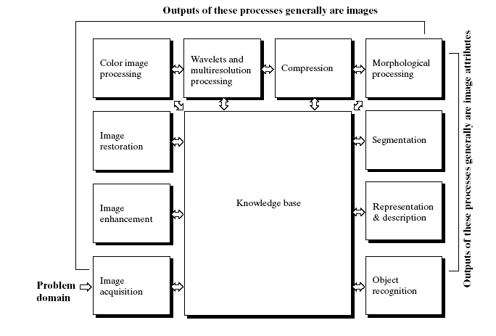

Figure 1.1 Fundamental steps in digital image processing.

**1.5 Components of an Image Processing System**

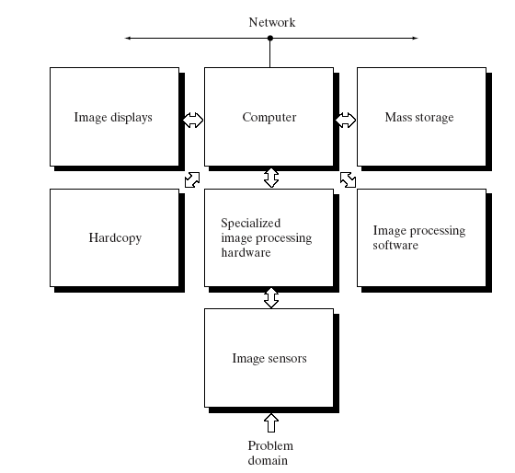

Figure 1.2 Components of an Image Processing System

Chapter 2

Digital Image Description

**2.1 Digital images**

A digital image is a discrete two-dimensional function f(x, y). Which has been quantized over its domain and range without loss of generality, it will be assumed that the Image is rectangular, consisting of Y rows and X columns. The resolution of such an image is written as XxY. By convention f(0, 0) is taken to be the top left corner of the image, and f(X - 1, Y - 1) the bottom right corner. This is summarized in figure 2.1

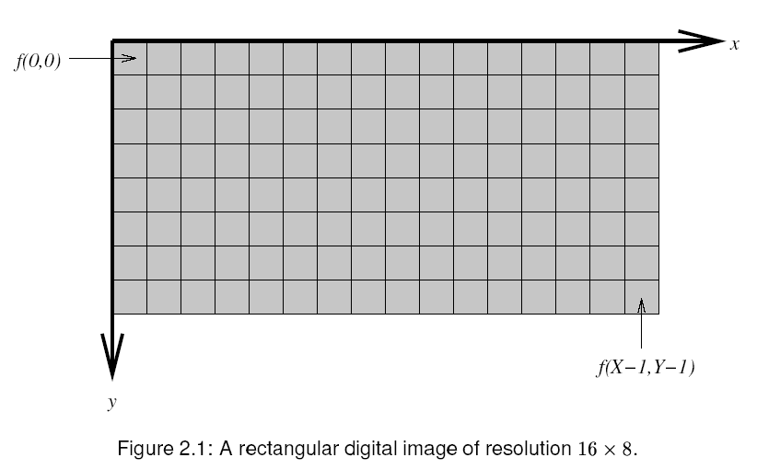

Each distinct coordinate in an image is called a pixel, which is short for "picture element ". The nature of the output of f(x, y) for each pixel is dependent on the type of image. Most images are the result of measuring a specific physical phenomenon Such as light, heat, Distance or energy. The measurement could take any numerical from.

|  |
| --- |
|  |

**2.2 Image file sizes**

Image files size expressed as the number of bytes—increases with the number of pixels composing an image, and the colour depth of the pixels. The greater number of rows and columns, the greater [image resolution](http://en.wikipedia.org/wiki/Image_resolution), and the larger the file. Also, each pixel of an image increases in size when its colour depth increases—an 8-bit pixel (1 byte) stores 256 colors, a 24-bit pixel (3 bytes) stores 16 million colors, the latter known as [truecolor](http://en.wikipedia.org/wiki/Truecolor).

**2.3 Pixel**

[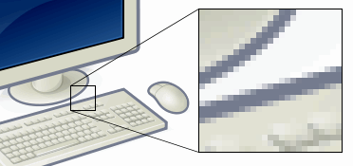](http://en.wikipedia.org/wiki/File:Pixel-example.png)

Fig 2.2 Pixels

This example shows an image with a portion greatly enlarged, in which the individual pixels are rendered as little squares and can easily be seen.

[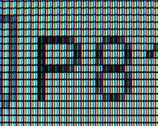](http://en.wikipedia.org/wiki/File:Closeup_of_pixels.JPG)

Fig 2.3 A photograph of Subpixels

A photograph of Subpixels, display elements on a laptop's [LCD](http://en.wikipedia.org/wiki/Liquid_crystal_display) screen.

In [digital imaging](http://en.wikipedia.org/wiki/Digital_imaging), a pixel, (picture element) is a single point in a [raster image](http://en.wikipedia.org/wiki/Raster_graphics), or the smallest addressable screen element in a [display device](http://en.wikipedia.org/wiki/Display_device); it is the smallest unit of picture that can be represented or controlled. Each pixel has its own address. The address of a pixel corresponds to its coordinates. Pixels are normally arranged in a two-dimensional grid, and are often represented using dots or squares. Each pixel is a [sample](http://en.wikipedia.org/wiki/Sampling_%28signal_processing%29) of an original image; more samples typically provide more accurate representations of the original. The [intensity](http://en.wikipedia.org/wiki/Intensity_%28physics%29) of each pixel is variable. In color image systems, a color is typically represented by three or four component intensities such as [red, green, and blue](http://en.wikipedia.org/wiki/RGB_color_model), or [cyan, magenta, yellow, and black](http://en.wikipedia.org/wiki/CMYK_color_model).

The word *pixel* is based on a contraction of *pix* ("pictures") and *el* (for "element"); similar formations with *el* for "element" include the words [Voxel](http://en.wikipedia.org/wiki/Voxel) and [Texel](http://en.wikipedia.org/wiki/Texel_%28graphics%29).

**2.4 Sampling patterns**

For convenience, pixels are normally arranged in a [regular two-dimensional grid](http://en.wikipedia.org/wiki/Regular_grid). By using this arrangement, many common operations can be implemented by uniformly applying the same operation to each pixel independently. Other arrangements of pixels are also possible, with some sampling patterns even changing the shape (or [kernel](http://en.wikipedia.org/wiki/Convolution_kernel)) of each pixel across the image. For this reason, care must be taken when acquiring an image on one device and displaying it on another, or when converting image data from one pixel format to another.

**2.5 Resolution of computer monitors**

Computers can use pixels to display an image, often an abstract image that represents a [GUI](http://en.wikipedia.org/wiki/GUI). The resolution of this image is called the display resolution and is determined by the [video card](http://en.wikipedia.org/wiki/Video_card) of the computer. [LCD](http://en.wikipedia.org/wiki/LCD) monitors also use pixels to display an image, and have a [native resolution](http://en.wikipedia.org/wiki/Native_resolution). Each pixel is made up of [triads](http://en.wikipedia.org/wiki/Triad_%28computers%29), with the number of these triads determining the native resolution. On some [CRT](http://en.wikipedia.org/wiki/Cathode_ray_tube) monitors, the beam sweep rate may be fixed, resulting in a fixed native resolution. Most CRT monitors do not have a fixed beam sweep rate, meaning they do not have a native resolution at all - instead they have a set of resolutions that are equally well supported. To produce the sharpest images possible on an LCD, the user must ensure the display resolution of the computer matches the native resolution of the monitor.

**2.6 Bits per pixel**

The number of distinct colors that can be represented by a pixel depends on the number of bits per pixel (bpp). A 1 bpp image uses 1-bit for each pixel, so each pixel can be either on or off. Each additional bit doubles the number of colors available, so a 2 bpp image can have 4 colors, and a 3 bpp image can have 8 colors:

* 1 bpp, 21 = 2 colors (monochrome)
* 2 bpp, 22 = 4 colors
* 3 bpp, 23 = 8 colors
* 8 bpp, 28 = 256 colors
* 16 bpp, 216 = 65,536 colors ("High color" )
* 24 bpp, 224 ≈ 16.8 million colors ("[Truecolor](http://en.wikipedia.org/wiki/Truecolor)")

For color depths of 15 or more bits per pixel, the depth is normally the sum of the bits allocated to each of the red, green, and blue components. [High color](http://en.wikipedia.org/wiki/Highcolor), usually meaning 16 bpp, normally has five bits for red and blue, and six bits for green, as the human eye is more sensitive to errors in green than in the other two primary colors. For applications involving transparency, the 16 bits may be divided into five bits each of red, green, and blue, with one bit left for transparency. A 24-bit depth allows 8 bits per component. On some systems, 32-bit depth is available: this means that each 24-bit pixel has an extra 8 bits to describe its [opacity](http://en.wikipedia.org/wiki/Opacity_%28optics%29) (for purposes of combining with another image).

**2.7 Image resolution**

Image resolution describes the detail an [image](http://en.wikipedia.org/wiki/Image) holds. The term applies to raster [digital images](http://en.wikipedia.org/wiki/Digital_image), film images, and other types of images. Higher resolution means more image detail.

Image resolution can be measured in various ways. Basically, resolution quantifies how close lines can be to each other and still be [visibly](http://en.wikipedia.org/wiki/Visual_perception) *resolved*. Resolution units can be tied to physical sizes (e.g. Lines per mm, lines per inch), to the overall size of a picture (lines per picture height, also known simply as lines, or TV lines), or to angular subtenant. Line pairs are often used instead of lines; a line pair comprises a dark line and an adjacent light line. A *Line* (or *TV line*, TVL) is either a dark line or a light line. A resolution of 10 lines per millimeter means 5 dark lines alternating with 5 light lines, or 5 line pairs per millimeter (5 LP/mm). [Photographic lens](http://en.wikipedia.org/wiki/Photographic_lens) and [film resolution](http://en.wikipedia.org/wiki/Film_resolution) are most often quoted in line pairs per millimeter.

|  |
| --- |
|  |

**2.7.1 Resolution of digital images**

The resolution of digital images can be described in many different ways.

**2.7.1.1 Pixel resolution**

The term *resolution* is often used for a [pixel](http://en.wikipedia.org/wiki/Pixel) count in digital imaging, even though American, Japanese, and international standards specify that it should not be so used, at least in the [digital camera](http://en.wikipedia.org/wiki/Digital_camera) field. An image of N pixels high by M pixels wide can have any resolution less than N lines per picture height, or N TV lines. But when the pixel counts are referred to as resolution, the convention is to describe the *pixel resolution* with the set of two positive [integer](http://en.wikipedia.org/wiki/Integer) numbers, where the first number is the number of pixel columns (width) and the second is the number of pixel rows (height), for example as *640 by 480*. Another popular convention is to cite resolution as the total number of pixels in the image, typically given as number of [megapixels](http://en.wikipedia.org/wiki/Megapixel), which can be calculated by multiplying pixel columns by pixel rows and dividing by one million. Other conventions include describing pixels per length unit or pixels per area unit, such as [pixels per inch](http://en.wikipedia.org/wiki/Pixels_per_inch) or per square inch. None of these *pixel resolutions* are true resolutions, but they are widely referred to as such; they serve as [upper bounds](http://en.wikipedia.org/wiki/Upper_bound) on image resolution.

[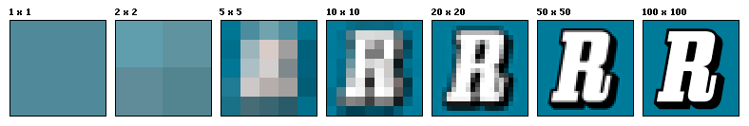](http://en.wikipedia.org/wiki/File:Resolution_illustration.png)

Fig 2.4 Resolution

An image that is 2048 pixels in width and 1536 pixels in height has a total of 2048×1536 = 3,145,728 pixels or 3.1 megapixels. One could refer to it as 2048 by 1536 or a 3.1-megapixel image.

**2.7.1.2 Spatial resolution**

[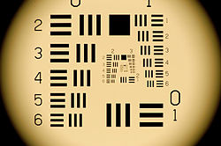](http://en.wikipedia.org/wiki/File:1951_USAF_Resolution_Test_Target.JPG)

Fig 2.5 Spatial resolution

The [1951 USAF resolution test target](http://en.wikipedia.org/wiki/1951_USAF_resolution_test_chart) is a classic test target used to determine spatial resolution of imaging sensors and imaging systems.

[](http://en.wikipedia.org/wiki/File:Matakis_-_blurred.jpg)[](http://en.wikipedia.org/wiki/File:MARTAKIS1.jpg)

Fig 2.6 Image at left has a higher *pixel count* than the one to the right, but is still of worse spatial resolution.

The measure of how closely lines can be resolved in an image is called spatial resolution, and it depends on properties of the system creating the image, not just the pixel resolution in [pixels per inch](http://en.wikipedia.org/wiki/Pixels_per_inch) (ppi). For practical purposes the clarity of the image is decided by its spatial resolution, not the number of pixels in an image. In effect, spatial resolution refers to the number of *independent* pixel values per unit length.

The spatial resolution of computer monitors is generally 72 to 100 lines per inch, corresponding to pixel resolutions of 72 to 100 ppi. With scanners, *optical resolution* is sometimes used to distinguish spatial resolution from the number of pixels per inch.

Chapter33

Importance of Image Processing

**3.1 Why image processing important?**

Image processing is a rapidly growing area of computer science. Its growth has been fueled by technological advances in digital imaging, computer processors and mass storage devices. Fields which traditionally used analog imaging are now switching to digital systems for their exibility and affordability. Important examples are medicine, _lm and video production, photography, remote sensing, and security monitoring. These and other sources produce huge volumes of digital image data every day, more than could ever be examined manually.

Digital image processing is concerned primarily with extracting useful information from images. Ideally, this is done by computers, with little or no human intervention. Image processing algorithms may be placed at three levels. At the lowest level are those techniques which deal directly with the raw, possibly noisy pixel values, with denoising and edge detection being good examples. In the middle are algorithms which utilize low level results for further means, such as segmentation and edge linking. At the highest level are those methods which attempt to extract semantic meaning from the information provided by the lower levels, for example, handwriting recognition.

# So, image processing is much important in our digital life.

# The continuum from image processing to computer vision can be broken up into low-, mid- and high-level processes

# 

# Fig 3.1 Image processing levels

**3.3.1 Image noise**

[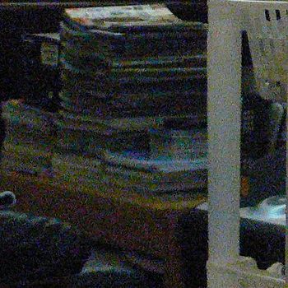](http://en.wikipedia.org/wiki/File:Highimgnoise.jpg)

Fig 3.2 Noise clearly visible in an image from a digital camera

Image noise is the random variation of brightness or color information in [images](http://en.wikipedia.org/wiki/Image) produced by the [sensor](http://en.wikipedia.org/wiki/Sensor) and circuitry of a [scanner](http://en.wikipedia.org/wiki/Image_scanner) or [digital camera](http://en.wikipedia.org/wiki/Digital_camera). Image noise can also originate in [film grain](http://en.wikipedia.org/wiki/Film_grain) and in the unavoidable [shot noise](http://en.wikipedia.org/wiki/Shot_noise) of an ideal photon detector.

Image noise is generally regarded as an undesirable by-product of image capture because it causes distortions present in the image that can obscure the subject of the photograph. Although these unwanted fluctuations became known as "noise" by analogy with [unwanted sound](http://en.wikipedia.org/wiki/Noise), they are inaudible and can actually be beneficial in some applications, such as [dithering](http://en.wikipedia.org/wiki/Dither).

**3.3.1.1 Amplifier noise (Gaussian noise)**

The standard model of amplifier noise is additive, Gaussian, independent at each [pixel](http://en.wikipedia.org/wiki/Pixel) and independent of the signal intensity, caused primarily by [Johnson–Nyquist noise](http://en.wikipedia.org/wiki/Johnson%E2%80%93Nyquist_noise) (thermal noise), including that which comes from the reset noise of capacitors ("kTC noise"). In color cameras where more amplification is used in the blue color channel than in the green or red channel, there can be more noise in the blue channel.

Amplifier noise is a major part of the "read noise" of an image sensor, that is, of the constant noise level in dark areas of the image.

**3.3.1.2 Salt-and-pepper noise**

[Fat-tail distributed](http://en.wikipedia.org/wiki/Fat_tail) or "impulsive" noise is sometimes called salt-and-pepper noise or spike noise.

An image containing salt-and-pepper noise will have dark pixels in bright regions and bright pixels in dark regions. This type of noise can be caused by dead [pixels](http://en.wikipedia.org/wiki/Pixel), [analog-to-digital converter](http://en.wikipedia.org/wiki/Analog-to-digital_converter) errors, bit errors in transmission, etc.

[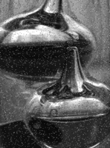](http://en.wikipedia.org/wiki/File:Noise_salt_and_pepper.png)

Fig 3.3 Image with salt and pepper noise

This can be eliminated in large part by using [dark frame subtraction](http://en.wikipedia.org/wiki/Dark_frame_subtraction) and by interpolating around dark/bright pixels.

**3.3.1.3 Shot noise**

The dominant noise in the lighter parts of an image from an [image sensor](http://en.wikipedia.org/wiki/Image_sensor) is typically that caused by statistical quantum fluctuations, that is, variation in the number of photons sensed at a given exposure level; this noise is known as photon [shot noise](http://en.wikipedia.org/wiki/Shot_noise). Shot noise has a [root-mean-square](http://en.wikipedia.org/wiki/Root-mean-square) value proportional to the square root of the image intensity, and the noises at different pixels are independent of one another. Shot noise follows a [Poisson distribution](http://en.wikipedia.org/wiki/Poisson_distribution), which is usually not very different from Gaussian.

**3.3.1.4 Quantization noise (uniform noise)**

The noise caused by [quantizing](http://en.wikipedia.org/wiki/Quantization_%28signal_processing%29) the pixels of a sensed image to a number of discrete levels is known as [quantization](http://en.wikipedia.org/wiki/Quantization_%28image_processing%29) noise; it has an approximately [uniform distribution](http://en.wikipedia.org/wiki/Uniform_distribution_%28continuous%29), and can be signal dependent, though it will be signal independent if other noise sources are big enough to cause [dithering](http://en.wikipedia.org/wiki/Dithering), or if dithering is explicitly applied.

**3.3.1.5 Film grain**

The [grain](http://en.wikipedia.org/wiki/Film_grain) of [photographic film](http://en.wikipedia.org/wiki/Photographic_film) is a signal-dependent noise, related to [shot noise](http://en.wikipedia.org/wiki/Shot_noise). That is, if film grains are uniformly distributed (equal number per area), and if each grain has an equal and independent probability of developing to a dark silver grain after absorbing [photons](http://en.wikipedia.org/wiki/Photon), then the number of such dark grains in an area will be random with a [binomial distribution](http://en.wikipedia.org/wiki/Binomial_distribution); in areas where the probability is low, this distribution will be close to the classic [Poisson distribution](http://en.wikipedia.org/wiki/Poisson_distribution) of shot noise; nevertheless a simple [Gaussian distribution](http://en.wikipedia.org/wiki/Gaussian_distribution) is often used as an accurate enough model.

**3.3.1.6 Anisotropic noise**

Some noise sources show up with a significant orientation in images. For example, [image sensors](http://en.wikipedia.org/wiki/Image_sensor) are sometimes subject to row noise or column noise. In film, scratches are an example of anisotropic noise.

**3.2 Image Enhancement**

Image enhancement approaches fall into two broad categories: spatial domain methods and frequency domain methods. The term *spatial domain* refers to the image plane itself, and approaches in this category are based on direct manipulation of pixels in an image. *Frequency domain* processing techniques are based on modifying the Fourier transform of an image. In our project we have worked only in the spatial domain because of the ease with which these operations can be parallelized, making them perfect for heterogeneous computing environment.

**3.3 Spatial Domain**

Spatial domainrefers to the aggregate of pixels composing an image. Spatial domain methods are procedures that operate directly on these pixels. Spatial domain processes can be denoted by the expression.



Where f(x, y) is the input image, g(x, y) is the processed image, and *T* is an Operator on *f*, defined over some neighborhood of (x, y).

The principal approach in defining a neighborhood about a point (x, y) is to use a square or rectangular sub image area centered at (x, y), as Fig 3.5 shows.



Figure 3.5 A 3*3 neighbourhood about a point (x,y) in an image.

**3.5.1 GRAY SCALE 8 BIT**

Images contain 256 possible shades of gray. A gray scale or grayscale [digital image](http://en.wikipedia.org/wiki/Digital_image) is an image in which the value of each [pixel](http://en.wikipedia.org/wiki/Pixel) is a single [sample](http://en.wikipedia.org/wiki/Sample_%28signal%29), that is, it carries only [intensity](http://en.wikipedia.org/wiki/Intensity) information. Images of this sort, also known as [black-and-white](http://en.wikipedia.org/wiki/Black-and-white), are composed exclusively of shades of [gray](http://en.wikipedia.org/wiki/Gray), varying from black at the weakest intensity to white at the strongest.

**3.5.2 RGB 24 bit**

24-bit color images are composed of (3) 8-bit color channels. Each color channel, similar to an 8-bit grayscale image, contains up to 256 colors. When combined, the red, green and blue channels provide up to 16.7 million colors. 24-bit color is also known as True Color and Photo-realistic Color. The RGB color model is an [additive color model](http://en.wikipedia.org/wiki/Additive_color) in which [red](http://en.wikipedia.org/wiki/Red), [green](http://en.wikipedia.org/wiki/Green), and [blue](http://en.wikipedia.org/wiki/Blue) light are added together in various ways to reproduce a broad array of [colors](http://en.wikipedia.org/wiki/Color). The name of the model comes from the initials of the three [additive primary colors](http://en.wikipedia.org/wiki/Primary_color#Additive_primaries), red, green, and blue.

**3.4 Color Image Processing**

In case of color image processing we have to consider all the three bands Red Green Blue and implement the same algorithm separately on them but in case of filters requiring comparison and summation we can do them in two ways.

**3.6.1 Considering the sum of the channels**

For comparison we add all the RGB values of a pixel and compare it with the summation of another and do the operations like swapping on all the values of the pixel depending on the result. This keeps the co-relation between the colors.

**3.6.2 Considering all the channels separately**

Here if we compare we do it individually for the three different colors and do the swapping, sorting and similar actions are done for each color differently.

**3.5 Image denoising**

Image denoising refers to the recovery of a digital image that has been contaminated by noise which arises during image acquisition (digitization) or transmission. The performance of imaging sensors is affected by the quality of the sensing elements themselves. For instance, in acquiring images with a CCD camera, light levels and sensor temperature are major factors affecting the amount of noise in the resulting image.

**3.5.1 Mean Filter**

Here the response of the filters is based on the different kind of means of the pixels, can be arithmetic mean, harmonic meant etc.

Mean filtering is a simple, intuitive and easy to implement method of http://homepages.inf.ed.ac.uk/rbf/HIPR2/mote.gifsmoothing images, i.e. reducing the amount of intensity variation between one pixel and the next. It is often used to http://homepages.inf.ed.ac.uk/rbf/HIPR2/mote.gifreduce noise in images.

The idea of mean filtering is simply to replace each pixel value in an image with the mean (`average') value of its neighbors, including itself. This has the effect of eliminating pixel values which are unrepresentative of their surroundings. Mean filtering is usually thought of as a http://homepages.inf.ed.ac.uk/rbf/HIPR2/mote.gif[convolution filter](http://homepages.inf.ed.ac.uk/rbf/HIPR2/convolve.htm). Like other convolutions it is based around a [kernel](http://homepages.inf.ed.ac.uk/rbf/HIPR2/kernel.htm), which represents the shape and size of the neighborhood to be sampled when calculating the mean. Often a 3×3 square kernel is used, as shown in Figure 1, although larger kernels (e.g. 5×5 squares) can be used for more severe smoothing. (Note that a small kernel can be applied more than once in order to produce a similar but not identical effect as a single pass with a large kernel.)

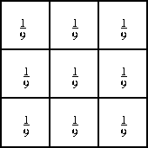  
Figure 3.7 3×3 averaging kernel often used in mean filtering

Computing the straightforward convolution of an image with this kernel carries out the mean filtering process.

## 3.5.2 K-Nearest Neighbor (KNN) Algorithm

### K Nearest Neighbor (KNN from now on) is one of those algorithms that are very simple to understand but works incredibly well in practice.

It is also a lazy algorithm. What this means is that it does not use the training data points to do any generalization. In other words, there is no explicit training phase or it is very minimal. This means the training phase is pretty fast. Lack of generalization means that KNN keeps all the training data. More exactly, all the training data is needed during the testing phase.

### KNN for Classification

Let’s see how to use KNN for classification. In this case, we are given some data points for training and also a new unlabeled data for testing. Our aim is to find the class label for the new point. The algorithm has different behavior based on k.

### Case 1: k = 1 or Nearest Neighbor Rule

This is the simplest scenario. Let x be the point to be labeled. Find the point closest to x. Let it be y. Now nearest neighbor rule asks to assign the label of y to x. This seems too simplistic and sometimes even counter intuitive.

### Case 2: k = K or k-Nearest Neighbor Rule

This is a straightforward extension of 1NN. Basically what we do is that we try to find the k nearest neighbor and do a majority voting. Typically k is odd when the number of classes is 2. Let’s say k = 5 and there are 3 instances of C1 and 2 instances of C2. In this case, KNN says that new point has to label as C1 as it forms the majority. We follow a similar argument when there are multiple classes.

**3.5.2.1 Some Example of KNN effects:**

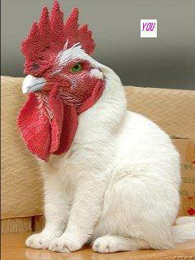

Fig 3.8 Before processing img_1

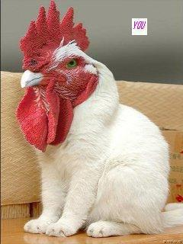

Fig 3.9 After processing img_1

Chapter 4

Adaptive Image Denoising based on Edge Detection

**References:**

1. Digital Image Processing. By- Rafael C. Gonzalez & Richard E. Woods
2. Adobe: [Digital Negative (DNG) - The public, archival format for digital camera raw data](http://www.adobe.com/products/dng/)
3. [The Sad Story of PNG Gamma "Correction"](http://hsivonen.iki.fi/png-gamma/)
4. RS-274X Extended Gerber Format Specification (Revision G), Published by Ucamco in December 2010, see <http://www.ucamco.com>
5. <http://en.wikipedia.org/wiki/Image_resolution>
6. <http://en.wikipedia.org/wiki/Pixel_density>
7. <http://www.mi.uib.no/BBG/RESEARCH/denoising.html>
8. <http://en.wikipedia.org/wiki/Digital_image_processing>
9. <http://en.wikipedia.org/wiki/Digital_image>
10. <http://www.answers.com/topic/digital-image>
11. <http://en.wikipedia.org/wiki/Digital_image_processing>
12. <http://homepages.inf.ed.ac.uk/rbf/HIPR2/median.htm>
13. <http://www.anirudh.net/courses/cse585/project1/>
14. <http://www.umiacs.umd.edu/research/EXPAR/papers/3449/node8.html>
15. MATLAB 7.6.0 (R2008a) (Help Section)
16. [CSE/EE 585: Digital Image Processing II](http://www.anirudh.net/courses/cse585/project1/)
17. [www.anirudh.net](http://www.anirudh.net)

**Appendix:**

**Code: (We have implemented these algorithms in MATLAB R2008a.)**